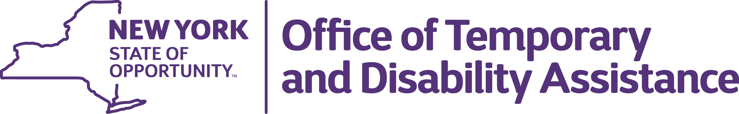
Andrew m. cuomo  Governor |  | Sharon Devine  Executive Deputy Commissioner

April 30, 2015

Dear Congregate Care Provider:

The purpose of this letter is to request your assistance in sharing with us a list of State Supplement Program (SSP) recipients residing at your facility, and helping us make sure we have the correct residence and mailing address for these individuals.

As the new administrative agency for SSP we rely on a number of sources, including SSA, the recipient and the Congregate Care provider community, to keep us informed of recipients’ contact information. Despite everyone’s best efforts, a significant amount of the mail we send out to recipients is returned by the Post Office. In an effort to ensure that notices, forms and benefits reach their proper destination, we are seeking your help.

Please provide us with the name, last 4 of the SSN and the residence and mailing address for each of your current SSP residents. We want to create as little additional work as possible for you, and will accept a locally produced report as long as it contains the requested information. Enclosed is a form that you may elect to use for this purpose.

I appreciate your cooperation. Please return this information by June 5, 2015 in one of the following ways:

- By Mail: NYS OTDA State Supplement Program, PO Box 1740, Albany, NY 12201
- By Fax: 518-486-3459
- By E-Mail: otda.sm.ssp@otda.ny.gov

Please direct any questions to the email address above.

Sincerely,

/s/ JH 4/30/15
John Haley
Director
SSI State Supplement Program

Enclosure

